1. Write a Python program to convert kilometres to miles?

Conversion rate of 1 Kilometre = 0.621371 Miles

*def convertKMtoMiles(kms):*

*convRate= 0.621371*

*try:*

*miles = kms \* convRate*

*print("%0.2f kilometers is equal to %0.2f miles" %(kms,miles))*

*except Exception as e:*

*print(e)*

*kms = float(input("Please enter the kilometers: "))*

*convertKMtoMiles(kms)*

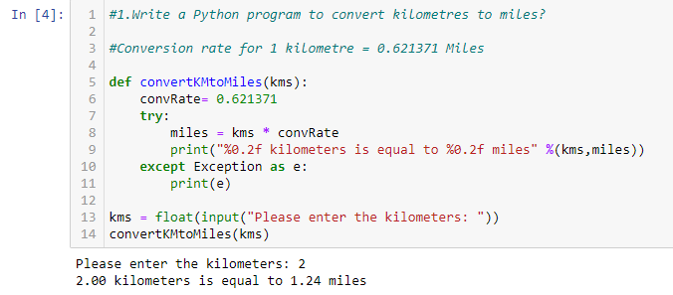

1. Write a Python program to convert Celsius to Fahrenheit?

Conversion rate 1 Celsius : 33.8 Fahrenheit

*def convertC2Fh(cel):*

*convRate= 33.8*

*try:*

*fah = cel \* convRate*

*print("%0.2f Celsicus is equal to %0.2f Fahrenheit" %(cel,fah))*

*except Exception as e:*

*print(e)*

*cel = float(input("Please enter the Celsicu: "))*

*convertC2Fh(cel)*

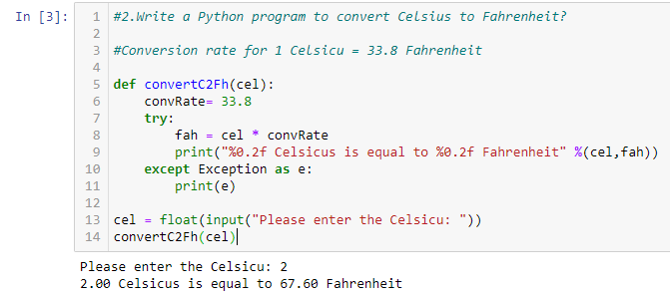

1. Write a Python program to display a calendar?

*import calendar*

*def showCalender(yy):*

*try:*

*if type(yy)== int:*

*print(calendar.calendar(yy))*

*else:*

*print("Please enter the year in YYYY format")*

*except Exception as e:*

*print(e)*

*showCalender(2022) #Calling the function*

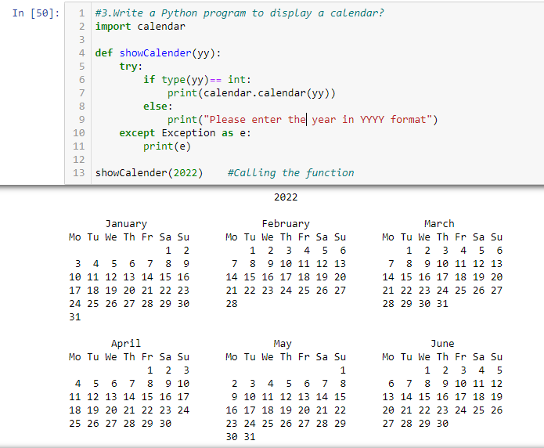

1. Write a Python program to solve a quadratic equation?

#Quadratic Equation ax2 + bx +c=0

*import math*

*# input values for a,b and c*

*a = float(input('Please enter value a: '))*

*b = float(input('Please enter value Enter b: '))*

*c = float(input('Please enter value c: '))*

*d = (b\*\*2) - (4\*a\*c) # calculate the discriminant*

*sol1 = (-b-cmath.sqrt(d))/(2\*a) # Solution 1*

*sol2 = (-b+cmath.sqrt(d))/(2\*a) # Solution 2*

*print('The solution are {0} and {1}'.format(sol1,sol2))*

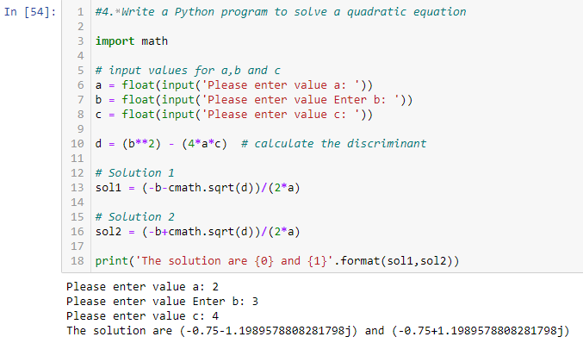

1. Write a Python program to swap two variables without a temp variable?

*x = 5 # x value is 5*

*y = 9 # y value is 9*

*x , y = y, x # swamp values from x to y and y to x*

*print(x)*

*print(y)*

